Experiment – 4

Create a simple cloud software application for Car Booking Reservation System using any Cloud Service Provider to demonstrate SaaS.
AIM:
To create a Car Booking Reservation System as a cloud-based SaaS application using Zoho Creator.
PROCEDURE:
1.Access Zoho Creator by logging in with a valid account and initiate the development process by creating a new cloud-based application to manage the car rental system.
2.Develop a Car Details form to record and manage essential vehicle information such as car model, registration number, rental rate, and availability status, ensuring accurate tracking of the fleet.
3.Create a Customer Details form to store important user information, including customer name, contact details, identification data, and other relevant records required for bookings.
4.Design a Booking or Reservation Details form and integrate it with both the Car Details and Customer Details forms using lookup fields, enabling a structured relationship between vehicles and customers for efficient reservation management.
5.Configure automated workflows within the application to calculate booking charges based on rental duration or rates and to automatically update the booking status, thereby improving accuracy and reducing manual processing.
6.Publish and deploy the completed application as a cloud-based service, allowing authorized users to access and manage bookings online.
7.Upon completing these configurations and deployment steps, the cloud-based car rental management software is successfully developed and made available for use.

IMPLEMENTATION:

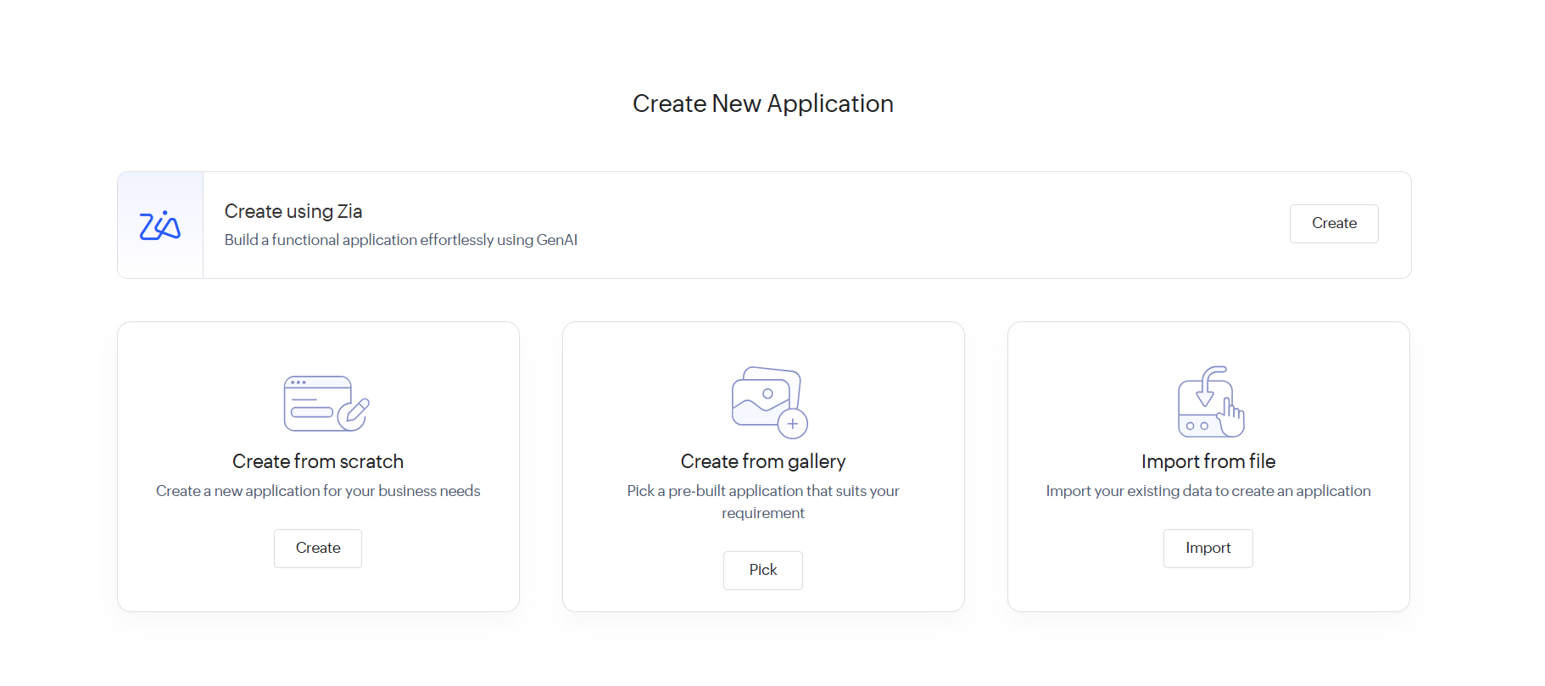
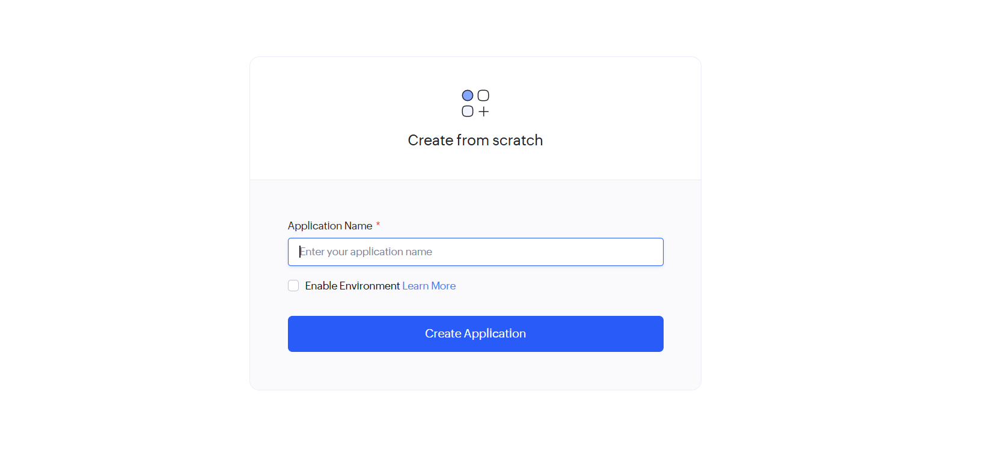
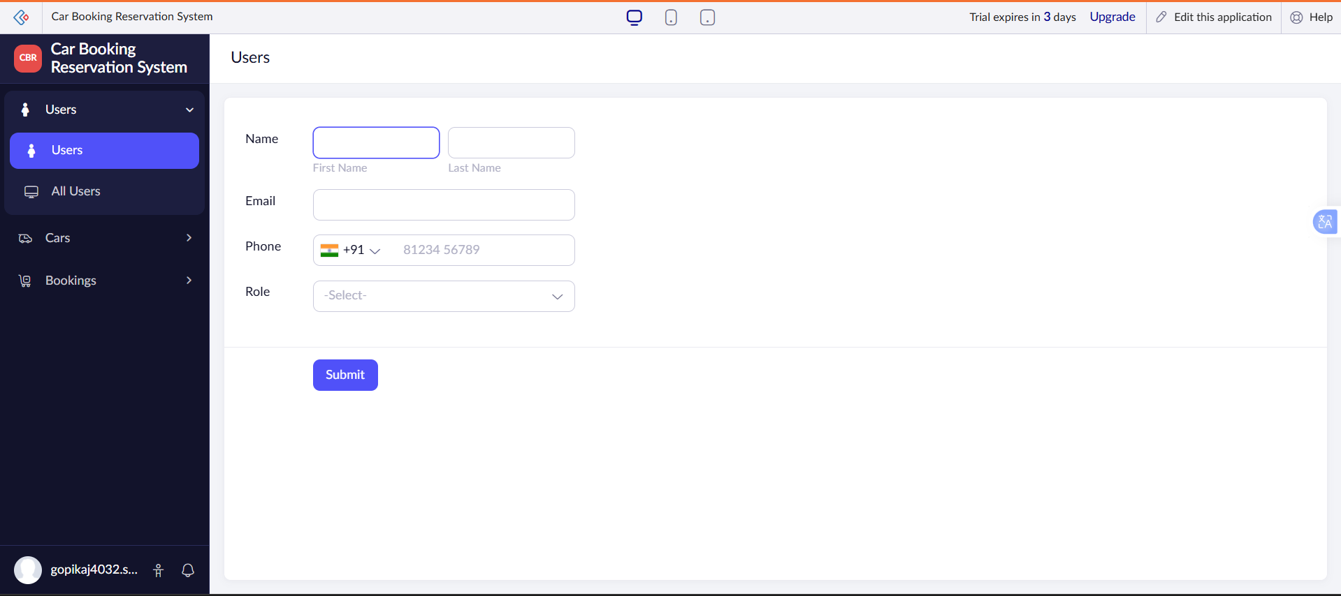

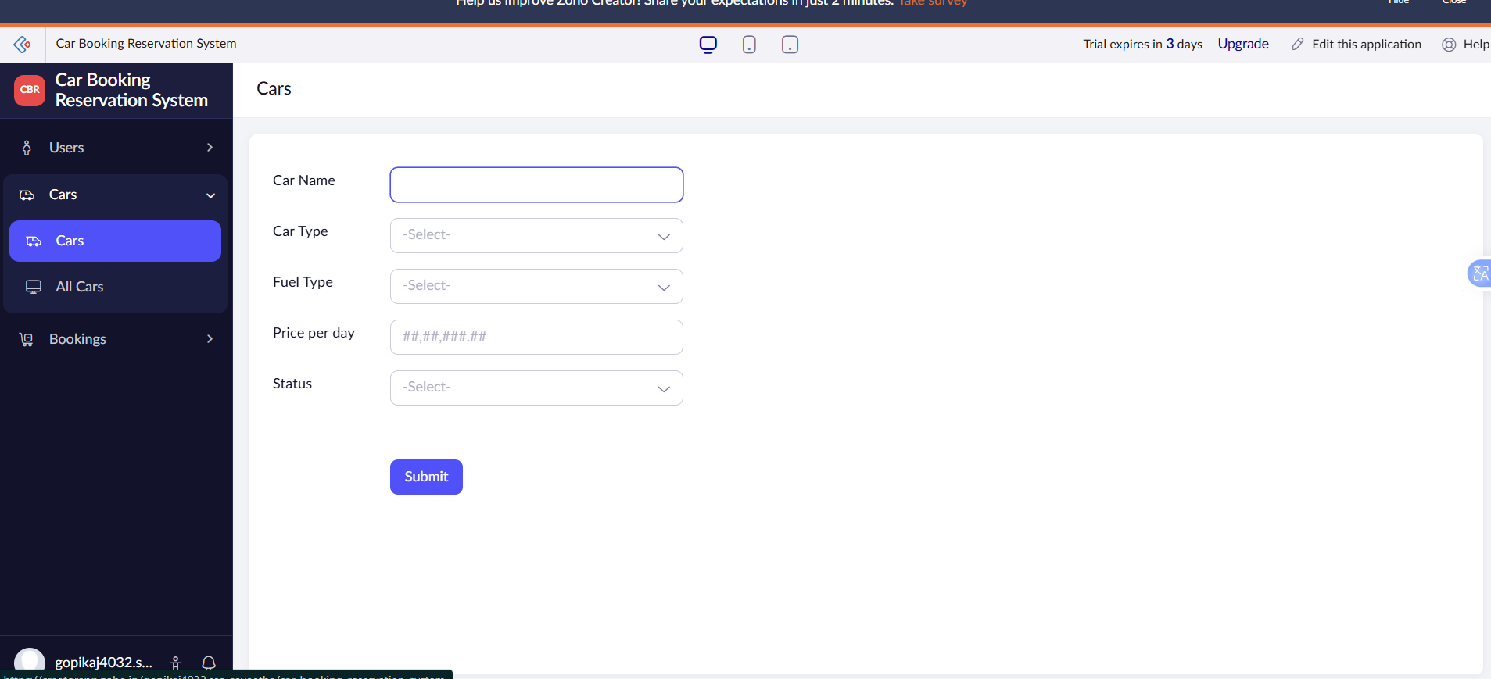

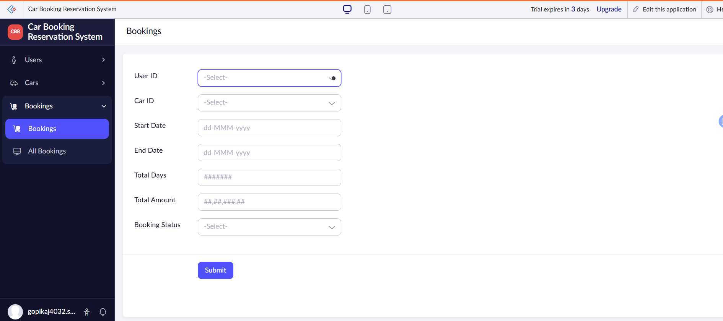

RESULT:
A cloud-enabled Car Booking Reservation System is successfully created as a SaaS application, allowing users to reserve cars online.

